UNIDAD 1 ETAPA 1—WS#1 NOMBRE: ________________________
PEOPLE, PROFESSIONS
When telling a person’s profession, the word a/an (un, una) is not used in Spanish.
Ex: He is a doctor. = Es doctor.

A. Identify each person by profession (Es doctor(a), maestro(a), estudiante, policía) and by boy/girl/man/woman (Es un chico, una chica, un hombre, una mujer).
1.  _____________________________________________________
2.  _____________________________________________________
3.  _____________________________________________________
4. _____________________________________________________
5.  _____________________________________________________
6.  ____________________________________________________
7.  _____________________________________________________
8.  ________________________________________________
UNIDAD 1 ETAPA 1—WS#2 NOMBRE: ________________________

SALUDES Y PRESENTACIONES

Choose the correct words to complete the following dialogues.
1. Paco: Hola, Teresa. ¿Cómo _____________________?
Teresa: ____________________, Paco. ¿Y _____________?
Paco: Regular, ____________________.
Teresa: Hasta luego, Paco.
Paco: Nos vemos, Teresa.

2. Emilio: Buenos días, Sra. Sánchez.
Sra. Sánchez: Buenos días, Emilio. ¿_______________ estás?
Emilio: Bien, gracias. ¿Y ________________?
Sra. Sánchez: Bien, gracias.

3. Diego: Buenas tardes, Sr. Ruiz.
Sr. Ruiz: Buenas tardes, Diego.
Diego: Sr. Ruiz, ________ presento a mi amiga Julia.
Sr. Ruiz: Mucho ______________, Julia.
Julia: __________________________, Sr. Ruiz.

4. Sara: Buenas noches, Sr. Díaz. ¿Cómo _________________ Ud.?
Sr. Díaz: Excelente, gracias. ¿________________ tú?
Sara: Muy bien, gracias.
Sr. Díaz: Sara, ________ presento a la nueva maestra, Sra. Flores.
Sara: ________________________, Sra. Flores.
Sra. Flores: El gusto es _________________, Sara.
Sr. Díaz: ___________________ mañana, Sara.
UNIDAD 1 ETAPA 1—WS#3 NOMBRE: ________________________
ME GUSTA, TE GUSTA, LE GUSTA

Tell what activity each person likes to do.
1. I:  _______________________________________________________
2. you:  _____________________________________________________
3. he/she:  __________________________________________________
4. you:  _____________________________________________
5. he/she:  ______________________________________________
6. I:  _____________________________________________________
7. you:  ________________________________________________________
8. I:  _______________________________________________________
9. he/she:  _________________________________________________
10. I:  __________________________________________________
UNIDAD 1 ETAPA 1—WS#4 NOMBRE: ________________________

SINGULAR SUBJECT PRONOUNS AND SER

The verb ser means “to be.” Here are the singular pronouns in Spanish and the corresponding forms of ser:
yo soy I am
tú eres you (familiar) are
él es he is
ella es she is
usted es you (formal) are
EX: Ella es una mujer. = She is a woman. Tú eres de Cuba. = You are from Cuba.
Yo soy doctor. = I am a doctor. Ud. es maestra. = You are a teacher.

Tell the following information about each person: profession, man/woman/boy/girl, what country they are from.

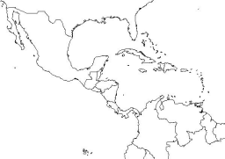1. Yo _______________________________________
Yo _______________________________________
Yo _______________________________________
2. Tú _______________________________________
Tú _______________________________________
Tú _______________________________________
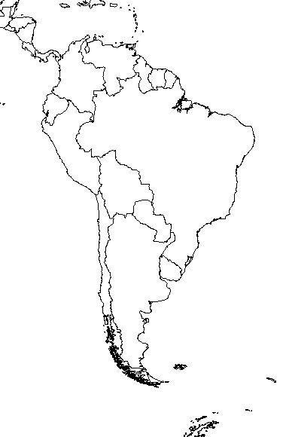
3. Él _______________________________________
Él _______________________________________
Él _______________________________________
4. Ella _____________________________________
Ella _____________________________________
Ella _____________________________________

UNIDAD 1 ETAPA 1—WS#5 NOMBRE: ________________________

PLURAL SUBJECT PRONOUNS AND SER

The verb ser means “to be.” Here are the plural pronouns in Spanish and the corresponding forms of ser:
nosotros somos we are
vosotros sois you all (familiar) are
ellos son they (masculine) are
ellas son they (feminine) are
ustedes son you all (familiar and formal) are
EX: Ellas son mujeres. = They are women. Uds. son de Cuba. = You all are from Cuba.
Nosotros somos doctores. = We are doctors. Ellos son chicos. = They are boys.

Tell the following information about each person:
Professions—doctores, doctoras, policías, maestros, maestras, estudiantes
People—hombres, mujeres, chicos, chicas
Where they are from
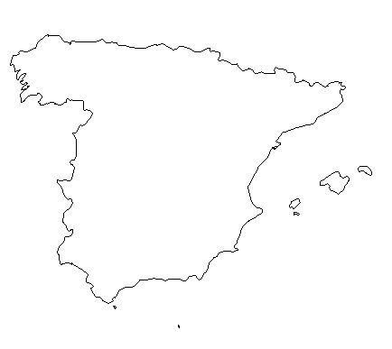
1. Ellas ______________________________________
Ellas ______________________________________
Ellas ______________________________________
2. Nosotros __________________________________
Nosotros __________________________________
Nosotros __________________________________
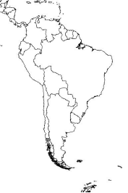
3. Ellas ______________________________________
Ellas ______________________________________
Ellas ______________________________________
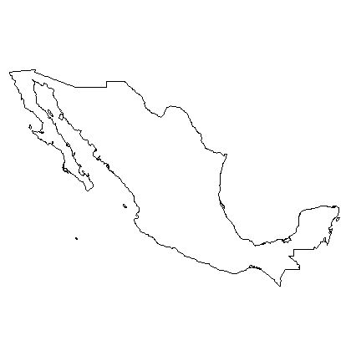

4. Ustedes ___________________________________
Ustedes ___________________________________
Ustedes ___________________________________

UNIDAD 1 ETAPA 1—WS#6 NOMBRE: ________________________

THE VERB SER

The verb ser means “to be.” Here are the six forms of ser.
yo soy = I am nosotros(as) somos = we are
tú eres = you (familiar) are vosotros(as) sois = you all (familiar) are
él es = he is ellos son = they (m, m & f) are
ella es = she is ellas son = they (f) are
usted es = you (formal) are ustedes son = you all (fam. & formal) are

A. Circle the correct form of ser to complete the sentence.
1. Yo (eres, soy) maestra de español.
2. Ella (es, son) mi amiga.
3. Tú (eres, somos) de Nicaragua.
4. Uds. (son, soy) hombres.
5. Nosotros (son, somos) de los Estados Unidos.

B. Write in the correct form of ser for each sentence.
1. Tú ______________ de Panamá.
2. Ella _______________ una mujer.
3. Ellos _________________ doctores.
4. Nosotros _________________ de Puerto Rico.
5. Yo __________________ maestra.

C. Write a subject pronoun to match the form of ser.
1. _______________ es una chica.
2. _______________ somos amigos.
3. _______________ son de Venezuela.
4. _______________ eres un hombre.
5. _______________ soy de la Argentina.

UNIDAD 1 ETAPA 1—WS#7 NOMBRE: ________________________

SUBJECT-VERB AGREEMENT
It is important to use the correct verb form to match the subject. Sometimes this is not immediately obvious because the subject is not a pronoun. For example:
Juan _______ doctor.
The subject “Juan” in the sentence can replaced with the subject pronoun “él.” The form of ser that matches “él” is “es.” Therefore, the sentence should read “Juan es doctor.”
Subject | Corresponding  subject pronoun | Form of ser
1 male | él | es
1 female | ella | es
person y yo | nosotros | somos
person y tú | ustedes (vosotros) | son (sois)
person y Ud. | ustedes | son
2 or more people (m, m& f) | ellos | son
2 or more people (f) | ellas | son

A. Give the corresponding subject pronoun for each noun.
EX: Julio y yo nosotros
1. Felipe y María _________________________
2. Felipe _________________________
3. María _________________________
4. Guido y yo _________________________
5. Paco y tú _________________________
6. Andrés y Ud. _________________________
7. Margarita _________________________
8. Sara y Luisa _________________________
9. tú y yo _________________________
10. el hombre _________________________
11. la chica _________________________
12. la maestra y yo _________________________

UNIDAD 1 ETAPA 1—WS#8 NOMBRE: ________________________
SER AND SPANISH-SPEAKING COUNTRIES (PART 1)
Use the map to tell where each person is from.
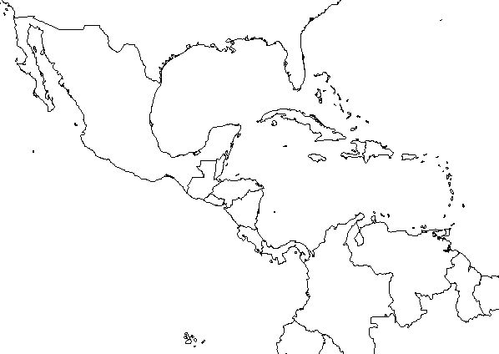
1
2
3
4
5
6
7
8
10
9

1. Francisco _______________________________________________________
2. Carlos y yo ______________________________________________________
3. Sara y tú _______________________________________________________
4. María y Teresa ___________________________________________________
5. Yo ____________________________________________________________
6. Enrique y Ud. ____________________________________________________
7. Tú ____________________________________________________________
8. La mujer _______________________________________________________
9. Mi amigo ________________________________________________________
10. Jaime y Luis _____________________________________________________
UNIDAD 1 ETAPA 1—WS#9 NOMBRE: ________________________
SER AND SPANISH-SPEAKING COUNTRIES (PART 2)
Use the map to tell where each person is from.
1
2
3
4
5
6
7
8
10
9
1. Tú ____________________________________________________________
2. Javier y yo ______________________________________________________
3. Yo ____________________________________________________________
4. El doctor _______________________________________________________
5. Víctor y Pilar _____________________________________________________
6. Luisa ___________________________________________________________
7. Diego y tú _______________________________________________________
8. El Sr. Pérez y Ud. _________________________________________________
9. Juan ___________________________________________________________
10. Ustedes ________________________________________________________

